Victor Anisi (PhD student)

COGCC Spill analysis report


INTRODUCTION
In approaching this project, attention should focus on the importance of taking a holistic approach to the risk assessment strategy in oil and gas operations to ensure safety for the public, protection of the environment, and operational reliability. Per Senate Bill 2013-202, since its enactment, COGCC has adopted a risk-based approach to conducting oil and gas location inspections. The COGCC targets inspections on operational phases at most risk from spills, excess emissions, and other violations. This directive constitutes an acknowledgment of the emergency need for a more rigorous inspection program that offers better protection for public health and safety and the environment. Our intent with this report is to provide a strong footing toward the development of a quantitative, statistically valid risk assessment model for flowlines. Currently, COGCC employs qualitative models that are flexible and easy to use but suffer from many serious limitations. These models are based on subjective assessments that have inherent potential biases and inaccuracies in the risk evaluations. The analysis of the current approach to assigning a risk score applies factors related to population density, environmental risk, number of reportable spills, years in service, operator performance history, and time since the last inspection. The nature of such an assessment is highly subjective; most provide little indication of complex interactions among the different risk factors.
This current report analyzes historical spill data presented by COGCC to identify key patterns and risk factors that will be used for developing an enhanced, more accurate, and more predictive risk model. This is not an exercise in mere theory; this is an essential transition from a qualitative approach toward a quantitative approach to risk assessment through state-of-the-art techniques in Data Science and Machine Learning. This will enable us to go beyond the limitations of the existing models and provide a better tool, not only for predicting where failures might occur but also for optimizing inspection protocols. The outcome of this analysis will be very instrumental in guiding us in our efforts to meet all the standards related to safety, health, and the environment as set by both COGCC and national standards. Of course, this work has broader implications than just Colorado itself. The conclusions from this report can be used to support efforts to improve safety and operational effectiveness nationwide as the industry continues to adapt to more and more data-driven methodologies.
This report undertakes an in-depth analysis of spill data for the period 2015 to 2022 to deliver key trends and patterns necessary for understanding the current risk landscape. The report describes the methodologies adopted, identifies the key findings, and discusses the implications of these findings for future risk assessment and management activities; it also offers recommendations on the best way forward. Using this information, we would try to devise a better risk model that could offer more efficient prediction to reduce not only the incidences of spills but most environmental hazards that result in detriments while improving decision-making and resource allocation for general oil and gas operations.

DATA OVERVIEW
In this section, we give an overview of the data used for our spill report analysis with both strengths and challenges associated with our examination. It is very important to understand these limitations as we go about developing a sound and practical quantitative risk assessment model for flowlines. The data set does include the types of spills, root cause, volume spilled, volume recovered, geographic coordinates, and operator information. The dataset is comprehensive over several years and provides a long-term view of ECMC's incidents of spills. Such a huge dataset is not devoid of significant gaps that present a challenge to our analysis. One of the main problems is that we have several missing values in many critical columns. Some of these columns like "Depth of Impact in Inches," "Other E&P Wastes," and several disposition descriptions had missing values at 100%. The missing data on this represents an important limitation since these kinds of attributes are very relevant to any environmental impact assessment or categorization of spills. For example, without information on the depth of impact, it is hard to establish the seriousness of the spill and/or possible environmental damage. In the same vein, the lack of information on "Other E&P Wastes" and disposition descriptions made our analysis of the characteristics of wastes that are associated with spill incidents not fully classifiable.
Furthermore, the data for this analysis was generated by combining two major data sources, namely "Spills" and "Flowline-Related Spills" datasets. From the merging of the aforementioned datasets using the “trkng_num” column as the primary key, we arrived at a total of 1,721 records of spill incidents dating from 2015 to 2022. Each record deals with a specific event of a spill that shows very important information at geographic locations, root causes, operator information, and the volume of the spill. In total, the combined dataset contains 34 features. While there are a great number of features in this dataset, for this analysis, five are the most relevant. The first is the variable Year_y, which indicates in which year each spill took place, allowing one to examine temporal trends to identify patterns over the years. These encompass the Root Cause Type column, which categorizes causes into vital areas for an understanding of fundamental operational failures or otherwise other factors that might have contributed to these incidents. The third feature is Basin, which covers geographic information that can help see how frequency varies across different basins. The fourth feature is Operator, which captures the company responsible for a spill and enables analysis of operator-specific trends. Lastly, different features of spill volume including oil_spilled, PW_spilled, cond_spilled, and other_spilled give the extent of each spill about the environment, hence providing the basis for the incident severity assessment.
In terms of the analyses performed, the trend analysis used all 1,721 records, focusing on the Year_y feature to track the number of spills per year from 2015 to 2022. In the spill types analysis, we examined the columns for oil_spilled, PW_spilled, cond_spilled, and other_spilled to understand the trend of different spill types over the same period, again using the full 1,721 records. The root cause analysis relied on the Root Cause Type column to investigate the common causes of spills and how they evolved from 2015 to 2022, utilizing all available records. In the operator analysis, we focused on the Operator feature to identify the top operators involved in spills. We used the full dataset but highlighted the top 10 operators with the highest incidents. Finally, in the basin analysis, we examined the Basin column to assess the geographic distribution of spills, using all 1,721 records to determine which basins were most affected.
Besides, from the flowline data given, the data for some salient features from 2015-2017 is unavailable, it was further observable that the unavailable data for these years is deeply specific to salient features that are supposed to encompass the flowline construction date, the pipe material, Maximum Outside Diameter (MaxOD), operating pressure, and fluid type. These features are important for a comprehensive, exact quantitative risk assessment model. For instance, knowledge of the date and material of construction for any flowline is critical in integrity assessments and judging the likelihood of failure. This is equally important as operating pressure and fluid type in the assessment of the risk of spills and their consequences. Without this information, our risk analysis has considerable blanks. The general rule is that a quantitative model cannot work unless it is based on a complete set of information with full coverage of all risk variables. In turn, the loss of information from 2015 to 2017 significantly restricts the possibility of accurately analyzing various trends and patterns, which is very important because otherwise, the results of risk assessment may turn out to be biased or incomplete. However, analysis was done using the available data from 2018 to 2022 and this will be highlighted extensively in future reports.
It is noteworthy to say that filling these gaps in the data will be an important ingredient in developing a robust and practically viable quantitative risk assessment model. This may involve seeking other sources of data, refining the data collection methodologies, or applying advanced techniques for the imputation of missing values. Identification of those challenges is considered essential for the validity and reliability of the development of the risk assessment model. By confronting these data challenges head-on, we can develop a more accurate and predictive risk model serving better the needs of ECMC and contributing to safer and more efficient oil and gas operations.

DESCRIPTIVE SPILL ANALYSIS
- Number of Spills Per Year
As shown in Fig. 1 the number of spills per year fluctuates from 2015 through 2022. Starting in 2015, the number of spills was 260 but reduced to 196 in 2017. From there, it went back up to 227 in 2018, whereas by 2020, it dropped even further to 158. Then, in 2021, they increased to 223 and slightly decreased again to 220 in 2022, a sort of stabilization. These divergences suggest that there is some reason for further consideration in the aspect of causes such as variations in regulation, enhancement of technology, operational practices, or external factors.
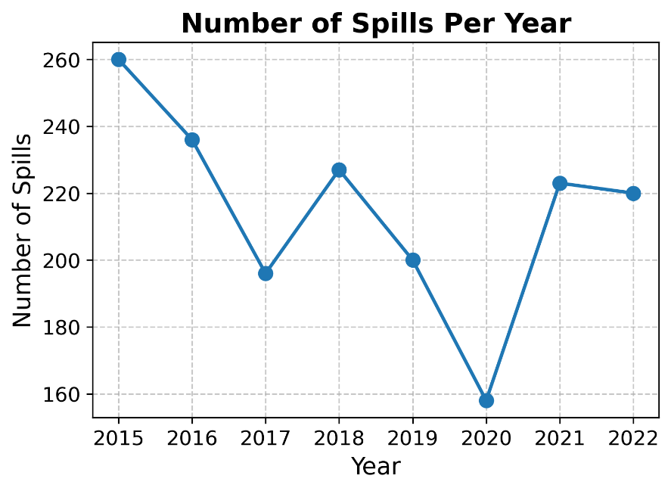

Fig. 1. Number of Spills Per Year (2015-2022)

- Spill Types over the Years
The Spill Types Over the Years shows the historical and recent spills from 2015 through 2022. In the context of the spill dataset, historical spills refer to incidents that were not immediately detected or reported, often occurring in the past but only discovered or documented at a later time. These spills typically show a delay between the actual event and its discovery, which can result in limited or incomplete data regarding the spill's immediate causes and consequences. In contrast, recent spills are those that were detected and reported promptly, with minimal delay between the occurrence of the spill and its discovery. This timely detection allows for more accurate and detailed documentation, including information on spill volumes, recovery efforts, and root causes. The key distinction between historical and recent spills lies in the timing of their detection, with recent spills providing more comprehensive and actionable data. In the dataset, this distinction can be inferred through the spill type feature, as recent spills are likely to have more complete records, while historical spills may require retrospective investigation due to delayed reporting. This difference in data quality and timeliness is critical when assessing trends and planning responses based on the spill information. In Fig. 2, the historical spills, which started in 2015, went linearly down until they stopped completely in 2020. On the other hand, recent spills that are reported each year between 2015 and 2022 are relatively stable, with a slight deterioration in 2020. The continuing recent spills indicate continuous challenges in the current operations.

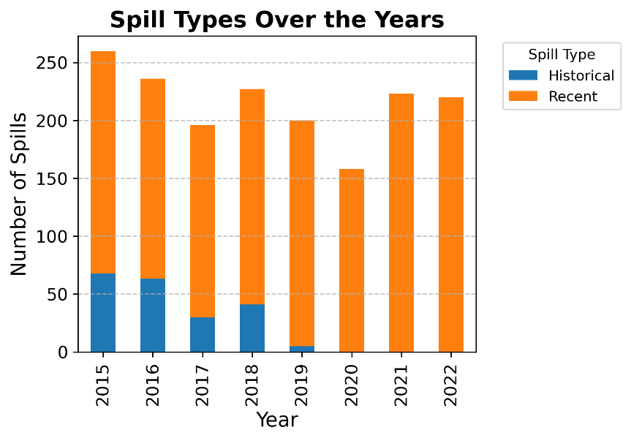

Fig. 2. Spill Types Over the Years

- Root Causes
The Root Causes show the trends in spill causes: from Fig. 3, the most dominant cause is corrosion, having gone down from 2015 to 2019, reflecting improvement in management, but rising slightly in 2020 and sharply in 2021. Equipment failure is trending up from 2015 to 2021, needing more improved maintenance and monitoring. The vibration of Incorrect Operation and Natural Force Damage is up and down, peaking at spikes in incorrect operations, such as the one in 2019, indicating variable but impactful human errors and other external factors. The trending unknown causes downwards indicate improvements in incident reporting and root cause identification.

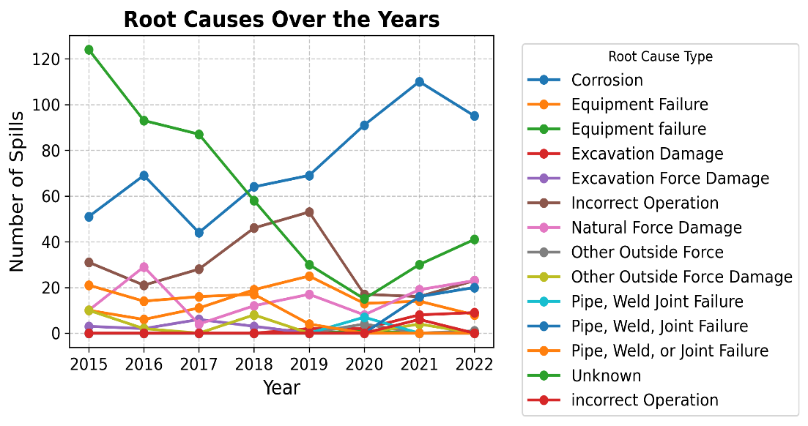

Fig. 3. Trend Analysis of Root Causes
- Spill Types vs Root Causes
The Spill Types vs. Root Causes heat map in Fig. 4 shows the relation between spill types and their causes. Corrosion is closely related to recent spills, with 550 incidents, underlining the challenge of pipeline integrity and aging infrastructure management. Incorrect Operation has surfaced as one of the top causes of recent spills, with 229 incidents-a sign of recurring operational errors. The unknown causes are notable for historical spills, underlining a deficiency in historical data and the need for improved root cause identification. Equipment Failure is significant both for recent spills at 104 incidents and historical ones at 2 incidents, underlining the importance of thorough equipment monitoring and proactive maintenance.
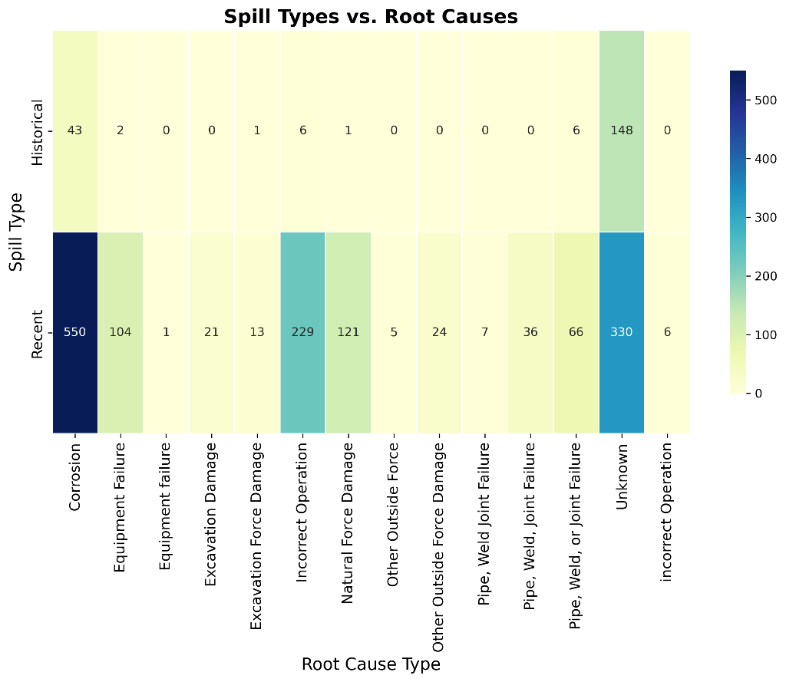

Fig. 4. Heatmap of Spill Types vs Root Causes

- Top 10 Operators Associated with Spill
The pie chart in Fig. 5 Noble Energy Inc. and Caerus Piceance LLC are in leading positions on the contributing list to the spills with 17.4% and 17.2%, respectively, for which focused risk management will be required. Chevron USA Inc., with 13.2%, and Bonanza Creek Energy Operating Company LLC, with 9.5%, also have a considerable share and their operations need further scrutiny. While operators like Kerr McGee Oil & Gas Onshore LP and Pioneer Natural Resources USA Inc. come with just much smaller percentages, they too contribute significantly to the totals and may need further follow-up, monitoring, and evaluation.
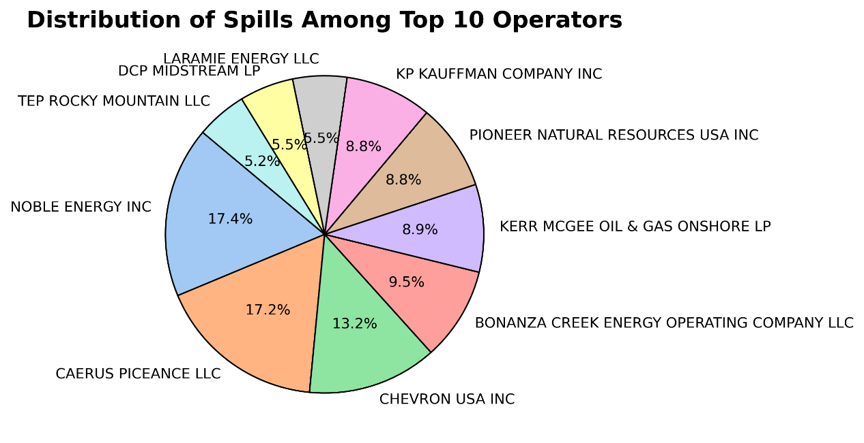

Fig. 5. Pie chart of Top Operators Involved in Spills

- Root Causes of Spills by Top Five Operators Associated with Spills
Common industry-wide problems are identified by leading root causes of spills as Corrosion and Unknown for Noble Energy Inc., Kerr McGee Oil & Gas Onshore, Chevron USA Inc., Caerus Piceance LLC, and Bonanza Creek Energy Operating Company. As shown in Fig. 6, Noble Energy Inc. has an unusually high number of spills classified due to Corrosion, which may signal pipeline integrity issues and indicate where additional maintenance or more rigorous monitoring is required. High counts of Unknown spills point to incident reporting or root cause analysis gaps. Similarly, Kerr McGee Oil & Gas Onshore shows many spills whose attributed Causes are listed as Unknown, while there is a strong need to improve the collection and analysis of data to find the real causes, together with those related to Corrosion and Incorrect Operation. Chevron USA Inc. similarly identifies Corrosion and Unknown as the top two causes of spills. However, the prevalence is slightly biased towards corrosion, underlining necessary enhanced corrosion prevention measures and infrastructure upgrade priorities, coupled with improved incident investigation procedures. From the given data, it is easy to understand that Caerus Piceance LLC experiences spill mainly due to Corrosion. That means infrastructure related, especially due to corrosion, are the key issue that needs much attention regarding investment in anti-corrosion technologies and regular inspections of pipelines. Bonanza Creek Energy Operating Company lists the primary cause as Corrosion, followed by Unknown, Incorrect Operation, and Equipment Failure, which shows that there is a need for a holistic approach to spill prevention, entailing equipment maintenance and personnel training for better operations. These large totals for unknown causes from all operators give evidence of huge gaps in incident investigation and reporting; this indicates that operators must develop better processes of data collection and analysis to enhance understanding of the causes of spills and hence adopt appropriate preventative measures.
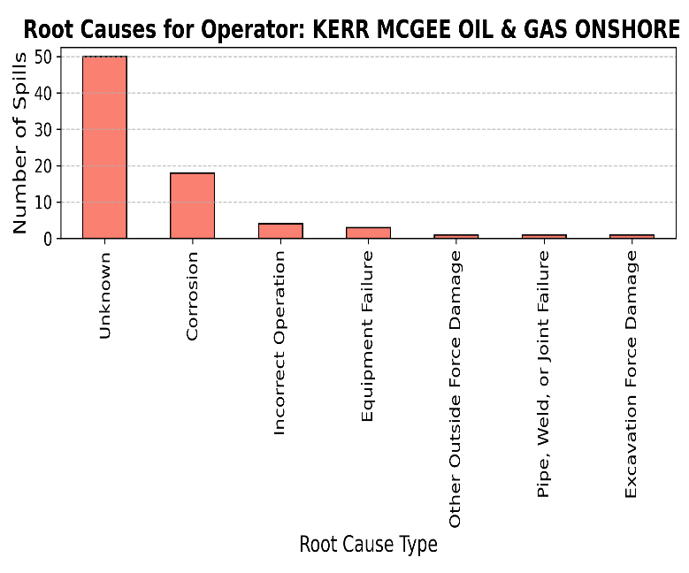
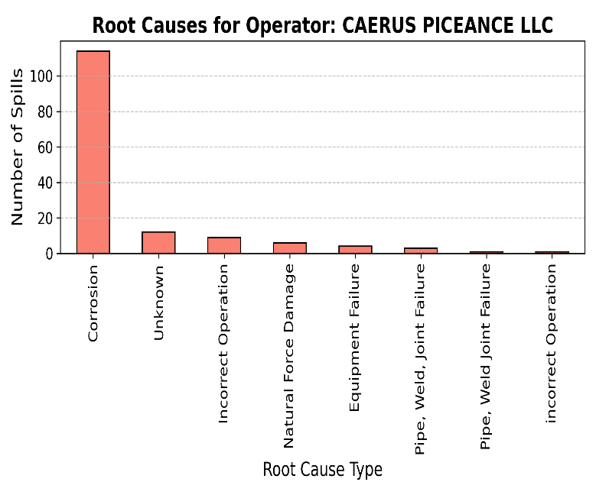
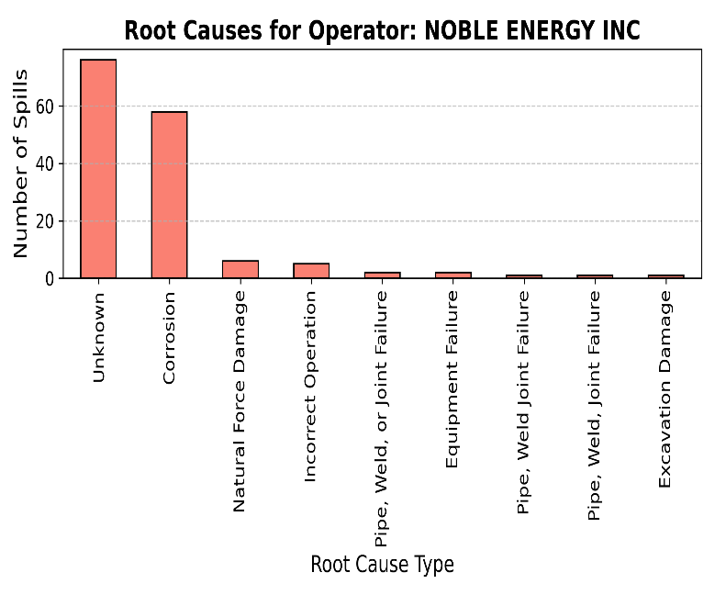
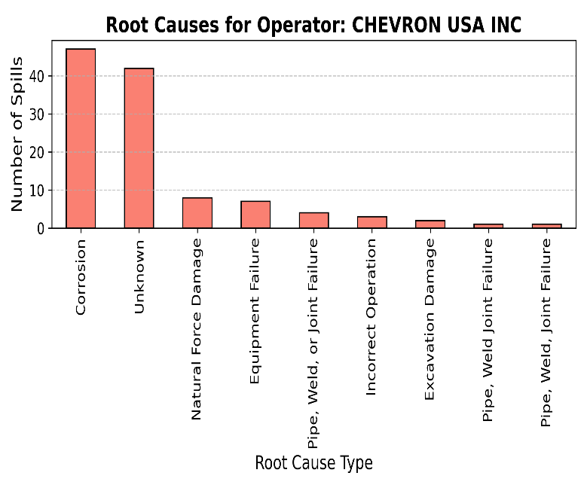
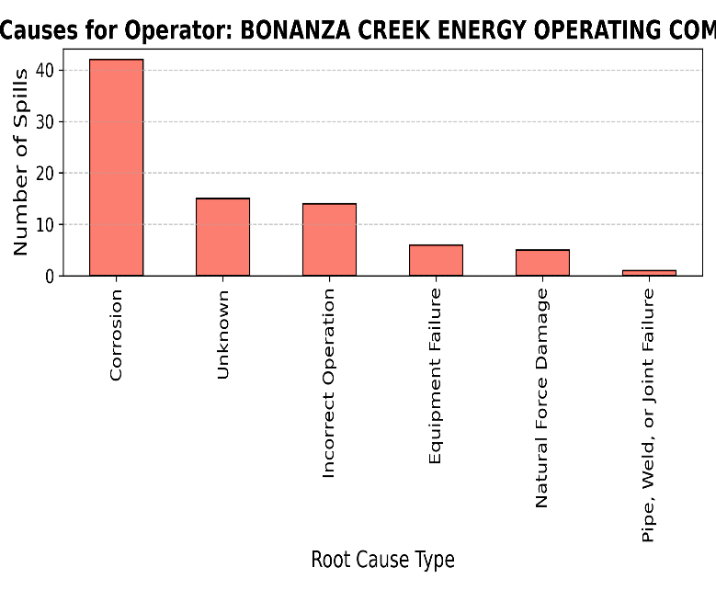

Fig. 6. Root Cause Type Associated with Top Operators

- Spill Types for Top Five Operators Associated with Spills

From Fig. 7, Noble Energy Inc.'s spill types fall closer to an even split between historical and recent, showing that both the company's legacy infrastructure management and current operations need critical review. This balance suggests that the company should have a greater focus on upgrading older equipment and improving its current practices to reduce spills. Most Kerr McGee Oil & Gas Onshore spills are Recent, indicating higher risks associated with recent operations and areas for improving maintenance protocols now. Chevron USA Inc. mostly has Recent spills but has a few Historical spills, which could be evidence that the older flowline infrastructures need to upgrade for an enhanced spill prevention. Caerus Piceance LLC reports almost all spills as Recent, showing a need to review current procedures and maintenance practices about minimizing risks. Bonanza Creek Energy Operating Company has dominant Recent spills, which again is an indication of active operational challenges that need immediate attention regarding spill prevention strategies. The general trend in more recent spills across operators would tend to indicate that current operations pose significant spill risks. This might imply that there is an industry need for better operational practices, and maintenance schedules.

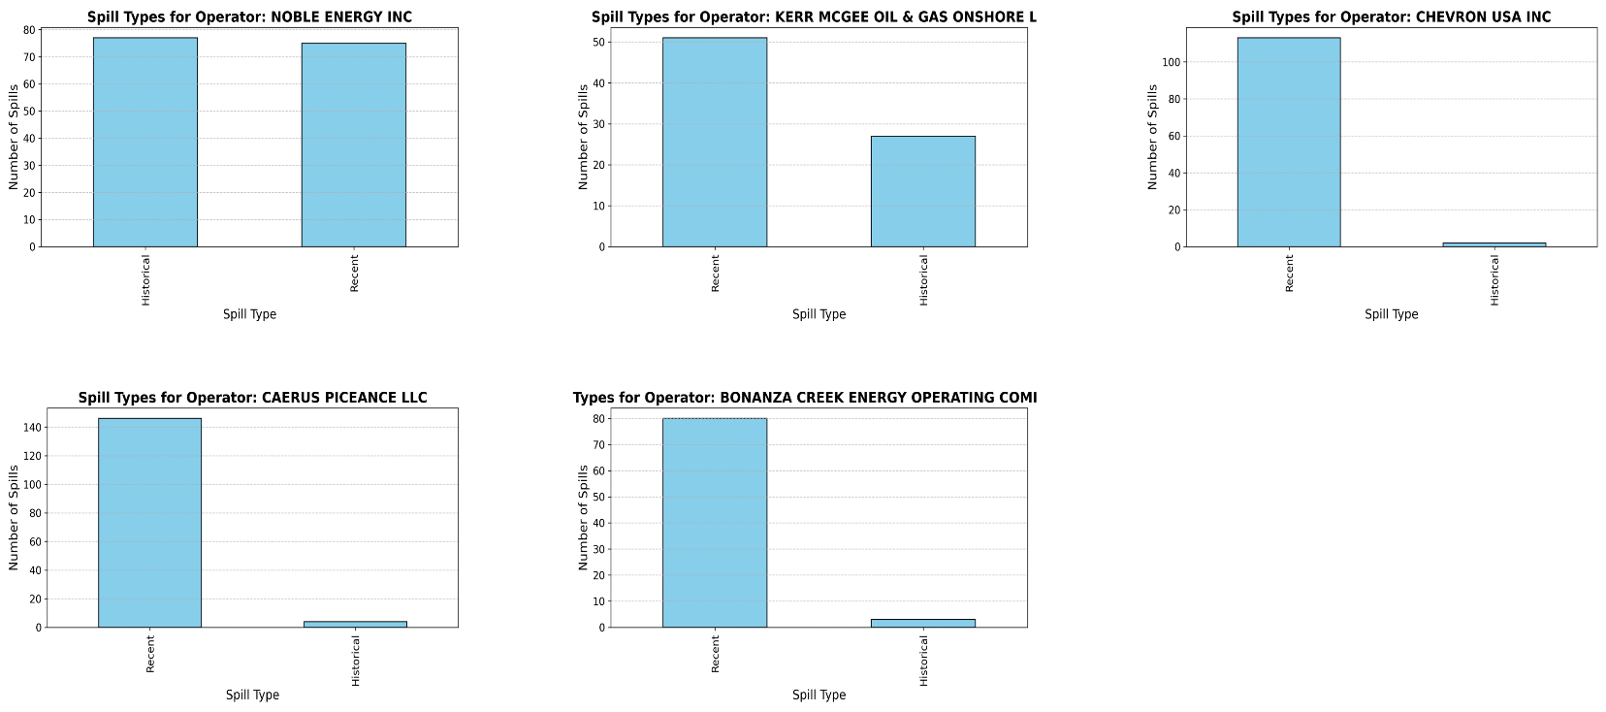

Fig. 7. Spill Types Associated with Top Operators

- Geographic Distribution of Spill Incidents
Analysis of the distribution of spill incidents by geography in Fig. 8a shows that these are still focused in areas with high oil and gas activities this can be seen clearly in Fig. 8b-for instance, in Denver-Julesburg Basin and Piceance Basin- pointing to an increasing intensity of operations regarding the likelihood of spills. These may be due to old infrastructure, complicated terrain, harsh weather, and environmental factors like soil type and groundwater level that raise the risk of pipeline failure and contamination. The key causes and intervention need for target areas in the analysis include increasing the level of maintenance, equipment upgrades, and region-specific risk management strategies as seen in Fig. 9 below.

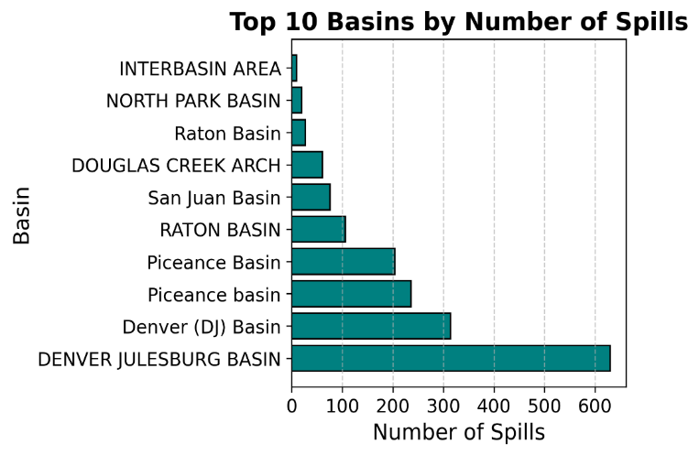
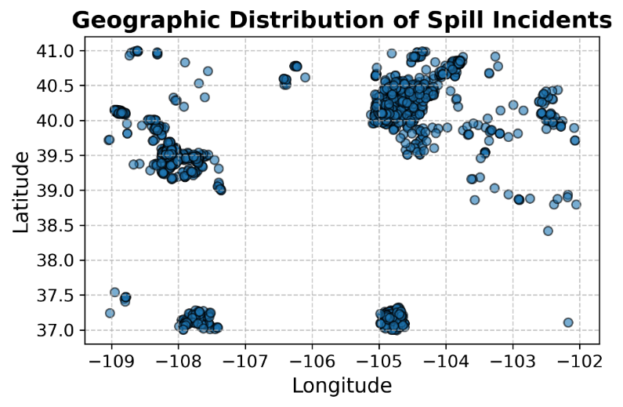
Fig. 8b. Basins with Most Spills
Fig. 8a. Geographic Distribution of Spills
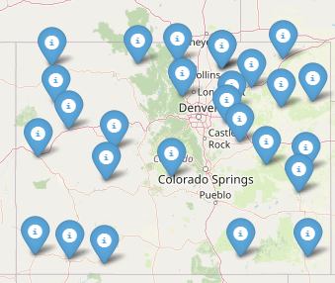

Fig. 9. Map of frequent Spill Locations

STATISTICAL SPILL ANALYSIS
Following the objectives of this project, the statistical experiments conducted on the dataset in this section are pivotal in extracting scientifically valid insights from the vast array of spill incident data collected from 2015 to 2022. The primary aim of these experiments is to identify and quantify patterns, correlations, and potential causative factors that contribute to spill incidents. This knowledge is instrumental in guiding ECMC towards better operational strategies, improving infrastructure resilience, and mitigating environmental risks. By performing these statistical experiments, we aimed to derive a deeper understanding of the relationships between various operational factors, geographic locations, and spill outcomes. Through chi-square tests, correlation matrices, and contingency tables, we can move beyond descriptive statistics to establish statistical significance and dependency between variables such as spill type, root cause, and basin. This allows us to pinpoint where preventive efforts should be concentrated, how effectively spill recovery efforts are being conducted, and where operational or infrastructural adjustments are necessary. Statistical analyses provide more than just patterns; they offer a method to quantify risk, predict future incidents, and evaluate the effectiveness of mitigation strategies. For this project, this statistical backbone will form the foundation for developing a predictive quantitative spill risk model, while enabling ECMC and operators to design tailored preventive maintenance programs and enhanced spill response strategies. Ultimately, the value of these statistical experiments is in their ability to inform data-driven decision-making, reduce future environmental impact, and ensure regulatory compliance, while improving operational efficiency.

- Spill Types and Root Causes- Chi-square Tests
A key area of investigation was understanding how different spill types are related to their root causes. We explored the relationship between the top three root causes—corrosion, incorrect operation, and unknown—and spill types using a contingency table and chi-square tests. In Fig. 10, oil and produced water spills exhibited the strongest relationship with corrosion as their root cause. This relationship was statistically significant, with chi-square values showing strong dependency (e.g., oil spilled had a chi-square statistic of 1689.49 with a P-value close to zero). This suggests that infrastructure failure, particularly due to aging pipes and corrosive materials, plays a large role in these incidents. The unknown category was also significantly linked to oil and PW spills, indicating that many spill incidents lack detailed investigation, making it harder to address their root causes effectively.

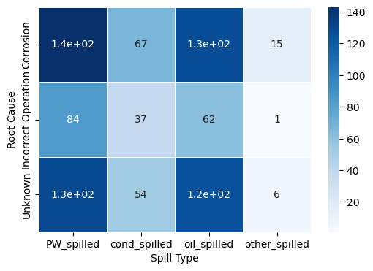

Fig. 10. Contingency Table for Root Causes and Spills

- Root Causes and Basins

We further investigated the relationship between the top three root causes (corrosion, incorrect operation, and unknown) and the top three basins (Denver Julesburg Basin, Denver DJ Basin, and Piceance Basin). This analysis was crucial for understanding the geographic spread of risk factors. The results in Fig. 11 show a strong correlation between the Denver Julesburg Basin and unknown-related incidents and corrosion-related incidents, where over 270 and 160 incidents were linked to these causes respectively. This geographic clustering of incidents related to specific root causes suggests that ECMC should focus its preventive measures on regions like Denver Julesburg, where corrosion and unknown operational failures are more prevalent. The Piceance Basin, while having fewer total incidents, also showed a notable correlation between corrosion and spill types, indicating that it, too, requires targeted attention.

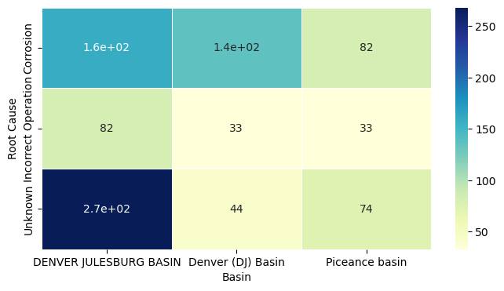

Fig. 11. Contingency Table for Root Causes and Basins

- Correlation Between Spill and Recovery Volumes
The correlation matrix between spill volumes and recovery volumes across all spill types reveals a strong positive relationship as shown in Fig. 12, indicating that ECMC’s recovery efforts are effective across the board. Specifically, oil spilled and oil recovered show a correlation of 0.82, demonstrating that a substantial proportion of oil is recovered as spill volumes increase. Condensate spilled and condensate recovered have an even stronger correlation of 0.91, reflecting highly efficient recovery practices for condensate spills. Produced water (PW) spilled and PW recovered correlate at 0.88, further underscoring the robust recovery mechanisms in place for PW spills. Additionally, the correlation between other spilled substances and their recovery volumes is exceptionally high at 0.98, suggesting that even for less common spill types, ECMC’s recovery strategies are highly effective. These consistently strong correlations across all spill types indicate that ECMC’s response mechanisms scale well with the size of the spills, ensuring efficient recovery in larger incidents.
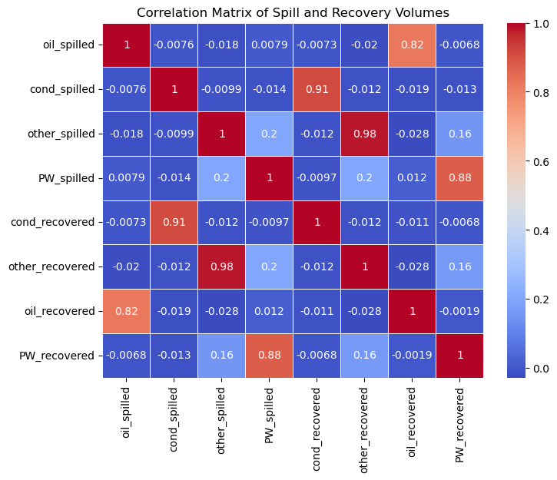

Fig. 12. Correlation Matrix of Spill and Recovery Volumes
- Chi-square Tests for Independence
The Chi-Square test is a statistical method used to assess whether there is a significant association between two categorical variables. In the context of this spill analysis, we applied the Chi-Square test to examine the relationship between spill volumes across different spill types (such as oil, produced water, condensate, and others) and their occurrence across various basins. This test is particularly useful for identifying whether certain types of spills are more likely to occur in specific geographic regions, which can provide insights into the underlying factors contributing to spills in particular areas. The null hypothesis in this test assumes that there is no association between the spill types and basin locations, meaning that the distribution of spill types is independent of basin regions. For oil spills, the Chi-square statistic was 1689.49, with an extremely low p-value of 9.09e-77. This indicates a statistically significant relationship, suggesting that oil spills are more likely to be concentrated in specific basins. Such concentration may be driven by regional infrastructure, environmental characteristics, or operational practices unique to these areas. In contrast, the Chi-Square test for condensate spills yielded a Chi-square statistic of 400.31 with a p-value of 1.0, demonstrating no significant association between condensate spills and basin locations. This implies that condensate spills are evenly distributed across basins, without favoring particular geographic regions. Produced water (PW) spills exhibited a Chi-square statistic of 2795.64 with a p-value of 4.47e-20, highlighting a significant association between the amount of PW spilled and specific basins. This finding suggests that certain basins are more prone to PW spills, potentially due to operational factors or the type of infrastructure present. Finally, the Chi-square test for other spill types resulted in a statistic of 66.75 with a p-value of 1.0, indicating no significant association between these types of spills and basin locations, suggesting that these spills are more evenly distributed across various regions. Overall, these results underscore that oil and PW spills are geographically concentrated in specific basins, while condensate and other spill types do not display such associations. This distinction is crucial for tailoring spill mitigation strategies to focus on regions where particular spill types are prevalent.
Conversely, it is important to highlight that correlation does not connote causation throughout these experiments. This is further showcased by the results from the Apriori analysis which yielded no association rules between spill types and root causes. This means that it is possible that there are no strong associations between the root cause types and spill types in the dataset under the current framework. This could suggest that while root cause types are related to spills, as indicated by the Chi-square analysis, they may not follow a consistent pattern of co-occurrence that can be easily captured by the Apriori algorithm. However, this lack of strong association may also be due to the high frequency of occurrence of unknown-related spill incidents which added a high degree of randomness to the dataset. Therefore, it is critical to balance these findings with practical domain knowledge.

RECOMMENDATIONS
By analyzing trends in the data over time, root causes, geographic patterns, and operator-specific insights, among others, several technical recommendations for further improvement of the industry in spill mitigation and prevention can be made. The recommendations in this section would address identified risk factors to refine operational practices and reinforce regulatory compliance to minimize environmental impacts while promoting the safe operation of activities.
1. Enhanced Corrosion Management and Mitigation Strategies
Corrosion has been cited as a leading cause of spills for several operators, strongly pointing to an industry-wide problem with pipeline integrity and/or maintenance. The integrity of the pipelines should be ensured by developing a comprehensive integrity management plan that includes periodic inspection and maintenance activities and continual monitoring of the pipeline condition. Advanced techniques used are ultrasonic testing, magnetic flux leakage, and inline inspection devices, also known as smart pigs, which help in the early detection of corrosion and other defects. The application of high-quality protective coatings and corrosion inhibitors to retard the rate of corrosion. Take into consideration, in the most aggressive environments where corrosion is expected aside from composite or other types of material. Consequently, supply and install cathodic protection systems for pipelines in soil areas with high corrosivity or areas where stray electric currents may interfere with the pipeline potential. Continuously monitor such systems for their effectiveness. Furthermore, develop a central data management system to record incidents of corrosion-related failures, maintenance records, and inspection data. Employ predictive analytics and machine learning algorithms to discover patterns in, and forecast potential, corrosion hotspots to allow proactive maintenance and mitigation of risk.
2. Enhance Data Collection, Reporting, and Root Cause Analysis
It is noteworthy that many incidents are attributed to unknown causes--pointing also to inadequacies in the collection of data and investigation into the causes of spills. Consistent, developed, and implemented data collection protocols for operations should be established to promote consistent reporting on spill incidents. This should include full documentation of the actual circumstances of spills concerning the contributing factors and corrective measures employed. Also, advanced root cause analysis (RCA) should follow a structured approach, like the "Five Whys" method or the "Fishbone Diagram," and carry out an in-depth probe into cases of spills to establish their root cause. Such knowledge must be utilized in implementing certain corrective and preventive measures. Similarly, investing in advanced incident management software integrated with the operational systems that exist, will be quick to facilitate the data gathering and incident reporting process, and the RCA process. Ensure tracking of incident investigations, corrective action assignments, and management and compliance reporting in real time are featured in the software. Ultimately, developing a structured training mechanism according to the needs of field personnel and incident investigators in coordinated data collection, methodologies for incident investigation, and strategies for root cause analyses. Ensure that all persons involved in the process are properly certification-competent and quite proficient in their respective roles.
3. Apply Operational Risk Management Best Practices.
The results thus show that most of the recent spills are due to operational factors, namely, incorrect procedure and equipment failure. Cycle review flows from the identification of potential hazards or effectiveness of measures adopted against operational risk during a periodical HAZOP, FMEA ranking, and so forth through a systematic re-evaluation of risks by teams, placing risk-mitigation efforts within budgetary priority. Again, there is a need to develop and put into operation integrated preventive maintenance programs for all critical equipment and infrastructures. Techniques such as condition-based maintenance (CBM) and reliability-centered maintenance (RCM) could be used for further improvement of the program in determining optimal scheduling, given the equipment's condition and the probability of its failure. These upscale monitoring and control systems will incorporate SCADA systems in a way where the operating parameters remain continuously under observation, and any abnormality is detected in real-time. Such systems would be connected with automatic shut-off valves and leak detector sensors to detect effectively in the event of a possible spill to minimize environmental impacts. Moreso, embedding the principles of human factors engineering into equipment and system design and operation to minimize the occurrence of human factors-induced errors is crucial. It would be effective for intuitive design in user interfaces, clear operating procedures, and adequate training and competence assessment of operators.

4. Reinforce regional and basin-specific risk management
The geographical spread analysis highlights areas and basins with high frequencies of spills, thus implying local risks that can require specific intervention. Hence, detailed risk profiles should be developed for each geographic region and basin through analyses of historical data on spills, environmental factors, and infrastructure attributes. Use Geographic Information Systems to depict spill hot spots geographically and pinpoint regions with greater levels of risk and store this data correctly in a way that a machine learning algorithm could be used to predict future spills before occurrence. Also, targeted inspections and interventions need to prioritize high-risk areas and basins for elevated levels of inspection, audit, and maintenance. Specialized teams conversant with regional risk factors must be deployed to undertake detailed assessments and recommend customized interventions. Consequently, regulators should engage with each other and establish rules and guidelines which are basin specific taking into consideration unique environmental and operational challenges. For example, enhance standards of pipeline integrity, corrosion management, and spill response for sensitive areas or areas of special risk. Similarly, proactively engaging local communities and indigenous peoples, as well as all other stakeholders will aid in the reduction of spills resulting from excavations and human activity through the establishment of information dissemination channels targeting to keep the stakeholders aware of all the activities of spill prevention and intervention plans.
5. Application of Advanced Technologies for Spill Identification and Control Observation
Quick identification and response to spills are crucial to minimizing environmental impact and lowering remediation costs. A leak can be detected in real-time with the aid of systems for real-time leak detection, such as fiber optic sensors, acoustic monitoring, and vapor detection technologies. Integrate these with central control rooms for 24/7 monitoring and rapid decision-making. Also, UAVs and drones have proven very helpful and useful because they utilize infrared cameras, gas sensors, and other highly advanced equipment to conduct aerial surveys, thereby spotting spills in terrain that are very difficult to operate. Besides this, drones can be used for post-incident assessment studies and environmental monitoring. Furthermore, one of the key deliverables for this project is to develop a machine learning model using past spill and flowline data in combination with operational parameters to forecast the likelihood of a spill event and pinpoint critical indicators. Using this insight in the implementation of proactive measures for the prevention of spills. Similarly, the use of augmented reality (AR) enabled training programs with spill response teams to learn how to simulate specific spill scenarios, followed by practicing appropriate response procedures in simulative environments is pertinent with long-term benefits. Such technology can heighten situational awareness, enhance decision-making processes, and build better response efficiency.
6. Build a Safety and Environmentally Conscious Culture Observation
Spill prevention and management must be an organizational-culture priority, with safety and environmental protection going hand in glove. There should be a visible commitment by senior leadership concerning safety and environmental stewardship. Establishing clear accountability for spill prevention and response from top executives to field personnel is crucial. Going forward, there is a critical need to develop safety management systems (SMS) that fully integrate policies, procedures, and performance measures for safety in all dimensions of field operations. Moreover, regularly reviewing and updating the SMS will aid in making room for changes in regulations and technology— and the evolution of industry best practices. Finally, establishing a culture of continuous improvement through the review of incident spills at periodic intervals, sessions to learn lessons, after-action reviews (AAR), and best practice dissemination will have a positive impact on overall environmental safety.
Conclusively, the implementation of these specific, technical recommendations should further enhance the preparedness and prevention of spills, reduce environmental impacts, and introduce safe and sustainable best practices by the COGCC, ECMC, and its stakeholders, while these recommendations are designed with unique issues under our spill review, they would also give an overall road map to achieve operational excellence for operators along with regulatory compliance across the oil and gas industry in the United States of America.

